**DRAFT**

**Overview of Current GTDS Pass Methodology for Specifying**

**An Override of Default Data Type Noise and Bias**

**With Sample Use Cases /**

**Overview of Three-Way Data Processing**

**Overview:**

The bias and noise attributes are set by data type in GTDS. Further, the internal FDF 4-character tracking station name is specially chosen, assigned, and implemented in GTDS’s unique station file to permit GTDS to key on and recognize which stations are of a particular data type. The fourth character of this specifically chosen 4-character station acronym ‘ACRN’ is the discriminator, where ‘N’ is the character that associates a data type with a station. The exception to this is DSN data where the first 2 characters ‘DS’ assign the DSN data type. Some of the DSN acronyms use the last character of ‘D’. The entries documented in this table are somewhat dated.

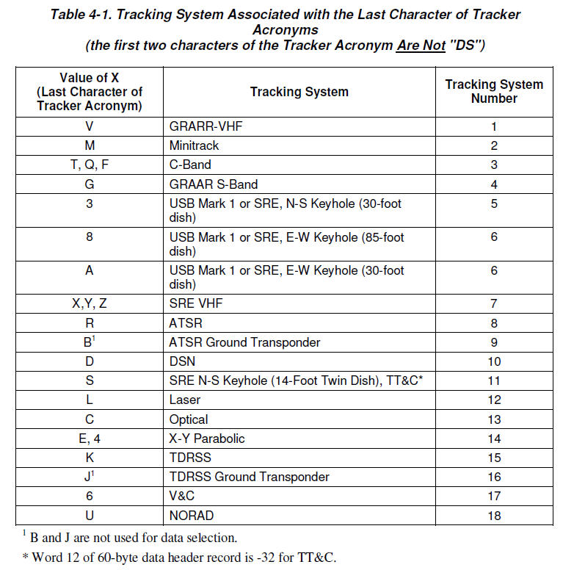

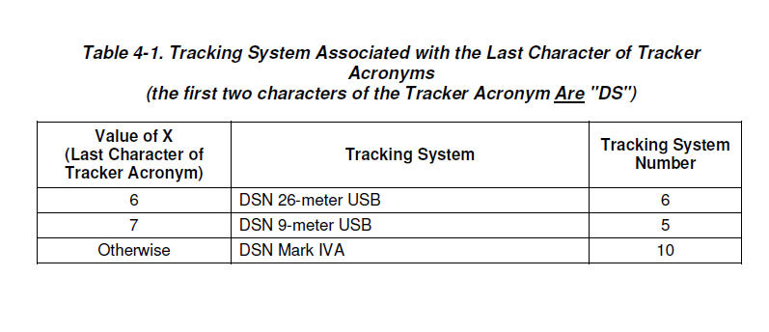

Some of the data types are now no longer used, or the specific data type is no longer supported and replaced with a newer data type. For instance, DSN data type Mark IVa is now replaced with DSN 2-34 but the GTDS User’s Guide table does not reflect that update for example.

To find the default settings for every data type, the GTDS user should consult Appendix A-2 from the GTDS User’s Guide shown below.

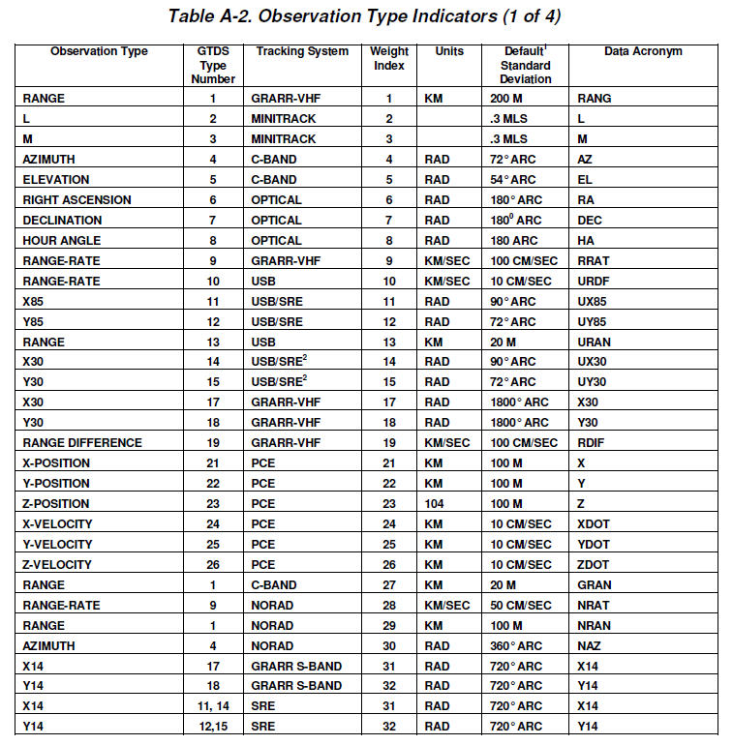

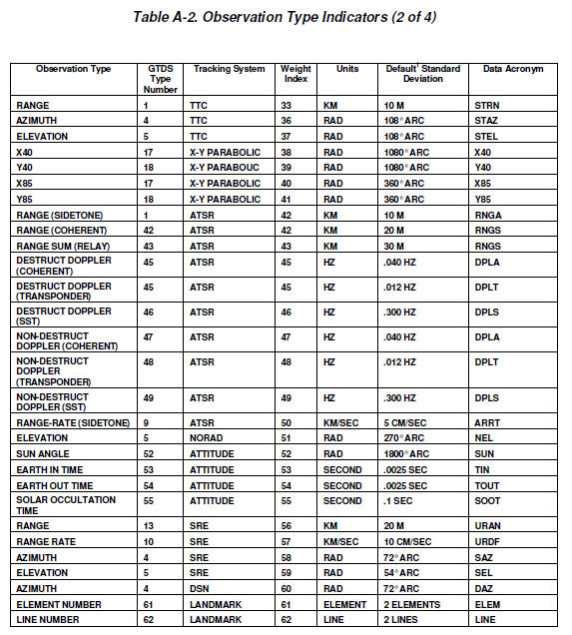

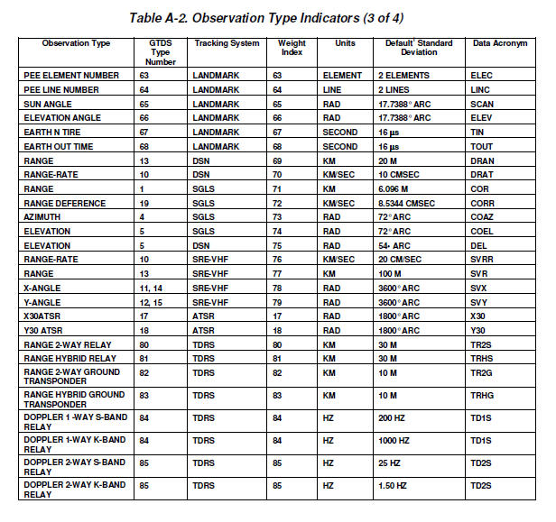

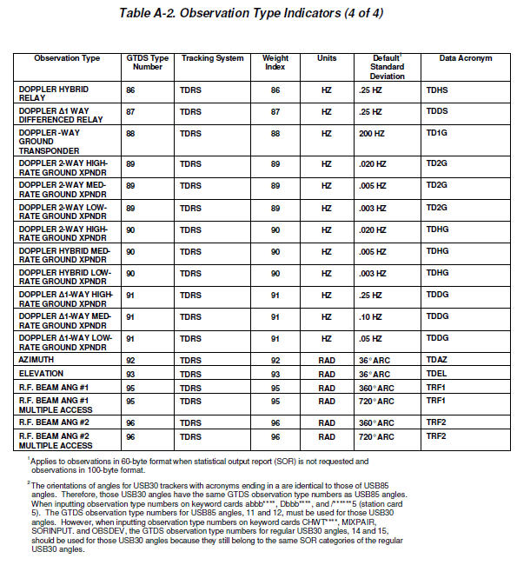

**Overriding Default Bias:**

In GTDS, the default bias settings can be overridden with the user of the Station 5 keycard. Like the case of solving for biases on a particular tracker’s data which is also achieved with the use of the Station 5 keycard, the settings are slightly altered so that instead of choosing to solve for the biases, instead a bias is applied to all data from an individual station. The user can choose to apply this bias for a specified time period or to all data from this data throughout the OD span.

**Example – Use of Station 5 card, setting a Doppler bias on all Doppler passes from one station:**

Station 5 card declaration:

/bbbbbbbb – for station name (cols. 1-8)

5 – col. 9 specifying pass dependent biases

0---+----1----+----2----+----3----+----4----+----5----+----6----+----7----+----8----+

DCOPT

/WS1S 5 10 4.0

A priori bias value.

Cols. 10-11

= blank for obs. bias

=1 for transponder delay

Cols. 12-14: Obs. type, from Table A-2.

The Doppler bias of 4.0 cm/sec will be applied to all data from WS1S throughout the OD run. It will not be solved for since the option to solve for it is not selected (non-zero entry in the third integer field in cols. 15-17 indicating how many passes the bias should be solved for). If a user wanted to apply a range bias to WS1S data, the ‘10’ in cols. 12-14 should be replaced with a ‘13’ for range data (from Table A-2 as above), and then select a range bias to be applied in cols. 18-38. For example putting a 30.0 in this column would indicate a range bias of 30.0 meters is being applied.

**Example – Overriding the Default Noise in GTDS**

The GTDS user has a choice of two GTDS keycards to override the default noise settings. The choice of card depends on whether the user is running with the Statistical Orbit Report (SOR) or not. In FDF, the typical user will be running the SOR report since the reports it generates are used in QA of the OD.

|  |  |
| --- | --- |
| **GTDS Case** | **GTDS Keycard to Use to Override Noise Settings** |
| SOR On | CHWT |
| SOR Off | OBSDEV |

Cols. 15-17: For TDRS chains, this field can indicate frequency band or antenna option or ground transponder selection

CHWT**** declaration:

**** – for station name (cols. 5-8)

If no station name present, will apply to all stations

0---+----1----+----2----+----3----+----4----+----5----+----6----+----7----+----8----+

DMOPT

CHWTWS1S 10 4.0

Cols. 60-80, a priori noise value

Cols. 10-11

Obs. type number, from Table A-2

Cols. 12-14: Tracker type number, from Table 4-1, optional

(

In this example, a priori bias noise value of 4.0 cm/sec is applied to all Doppler data from the ground station WS1S.

The other option to set a different noise value is the use of the OBSDEV card. This option can only be used when the GTDS user is not generating an SOR report.

0---+----1----+----2----+----3----+----4----+----5----+----6----+----7----+----8----+

DMOPT

OBSDEV 11 12 360. 360.

New noise standard deviation for data

Cols 9-11:Weight Index for data type 1 (from Appendix A-2)

Cols. 12-14: Weight index for data type 2 (from Appendix A-2)

Cols. 15-17: Weight index for data type 3 (from Appendix A-2)

In this example, the angle types 11 and 12 which corresponds to USB/SRE are changed to a new standard deviation of 360 radians.

**Three-Way Data Processing:**

As background to the discussion of setting up a different bias and noise from an uplink to a satellite to a separate downlink site as in 3-way data, more information on understanding 3-way data processing is discussed first below.

Three-way data processing is very complex at the tracking networks level and subsequent OD processing. There are many reasons for this. One of the prime reasons is that tracking is normally performed across multiple government and commercial tracking networks in support of NASA missions. These networks have a variety of tracking equipment installed over decades of time, each with its own capabilities and its own constraints, with their own staff and ground equipment and software. Many of the newer antennas have digital equipment and are subject to limitations in the numerically controlled oscillator settings. Many of the newer equipment might be shared at sites but also have different ground station processing software.

To gain the benefit of improved OD benefits with a more geometric separation from a separate uplink and downlink site in 3-way data processing, it is important that the uplink frequency be very accurately known. However, the exact uplink frequency is usually not conveyed in the tracking record sent. Differences in the expected and exact frequencies can cause huge differences in the tracking measurements. (This will dwarf any single expected differences in bias or noise settings adjustments). Further, there is not a provision within and across networks to share the actual uplink frequency with a down-range site, even if they were prepared procedurally and operationally to do so. The only way to manage this is to have someone be a coordinator for all affected sites to come up with a frequency plan that considers and addresses the limitations in all equipment and sites for a fixed period of time and selects frequencies to be used for all sites for a specific mission. The NEN, and other commercial networks that support NASA utilize the UTDF data format, and it only allows the uplink frequency to be specified to within 10 Hz, so this must also be addressed. Further, some of the commercial trackers don’t have a mechanism to mark data as 3-way without a software upgrade, so this change must be accommodated at the OD processing site. Also, since data arrives at the OD sites with different delays, the tracking data ground system must be able to match up 3-way data with the correct 2-way transmit site. The transmit site will be blank on a 3-way tracking record or one incorrectly flagged as 1-way as the site is not known.

The only way to address some of these items is to have a frequency sharing plan that is complex to set up in advance and that the stations must adhere to over a set time period. It also requires that the networks down to individual antenna operators adhere to the plan. This would normally have to be set up by the FDF for example and it would have to be shared with all the networks and ground station support staff. The plan has to take in account issues with newer digital antennas not being able to dial it to a specific frequency without a remainder. Also, the frequency plan must take into account the turnaround ratio for the uplink/downlink and take into account the individual equipment and ranging equipment available at each tracking site. So the frequency sharing plan has to work for all equipment across all networks. And then during the actual tracking, the frequency sharing plan cannot be deviated from.

For instance, the DSN network will normally perform a frequency sweep to acquire a satellite at first acquisition. The frequency at which they acquired may not be the frequency that they plan for a particular satellite but some offset from that. So they would have to be asked to deviate from their normal procedures and to not sweep for the satellite but to try to acquire at a locked frequency.

In reviewing the GTDS User’s Guide and the Fortran code, within GTDS there seems to be no mechanism for using a different bias and noise value setting for the downlink leg at the second station from that of the uplink station in the case of 3-way data specifically. It is hard to say that with complete certainty due to the huge amount of GTDS code. Also, after review of the GTDS User’s Guide, no specification appears available for this case of 3-way data (to set different bias and noise for the uplink and downlink). Although there is some capability to apply bias and noise to some limited chains though not two ground sites in a 3-way configuration. However, as noting the issues above, this may be not as valuable at the present time.